SET 17: Employee Performance Analysis
Aim
To visualize and analyze employee performance data using a line chart, bar chart, table, and a Tableau dashboard.
Data: EMPLOYEE PERFORMANCE
Employee ID | Department | Years of Service | Performance Score
1 | Sales | 5 | 85
2 | HR | 3 | 92
3 | Marketing | 7 | 78

PROGRAM 1: Line Chart of Employee Performance
Create a line chart to visualize employee performance against years of service.
library(ggplot2)

employee <- data.frame(
Employee_ID = c(1, 2, 3),
Department = c("Sales", "HR", "Marketing"),
Years_Service = c(5, 3, 7),
Performance_Score = c(85, 92, 78)
)

ggplot(employee, aes(x = Years_Service,
y = Performance_Score)) +
geom_line(color = "blue", linewidth = 1) +
geom_point(color = "red", size = 3) +
labs(
title = "Employee Performance by Years of Service",
x = "Years of Service",
y = "Performance Score"
) +
theme_minimal()
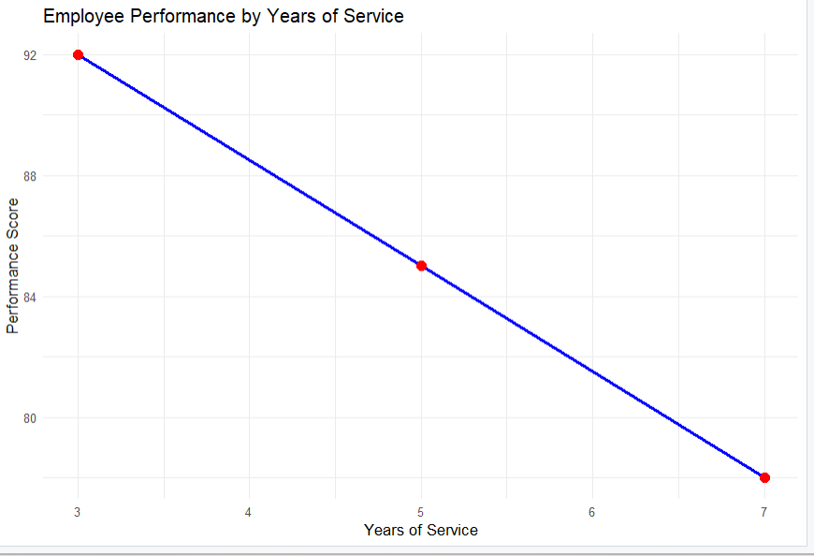
Output 1: Employee Performance Line Chart
Observation: The line chart compares performance scores with years of service. The employee with 3 years of service has a score of 92, the highest among the three employees.

PROGRAM 2: Bar Chart of Employees by Department
Generate a bar chart showing the distribution of employees across departments.
library(ggplot2)

employee <- data.frame(
Employee_ID = c(1, 2, 3),
Department = c("Sales", "HR", "Marketing"),
Years_Service = c(5, 3, 7),
Performance_Score = c(85, 92, 78)
)

ggplot(employee, aes(x = Department)) +
geom_bar(fill = "orange") +
labs(
title = "Number of Employees by Department",
x = "Department",
y = "Number of Employees"
) +
theme_minimal()
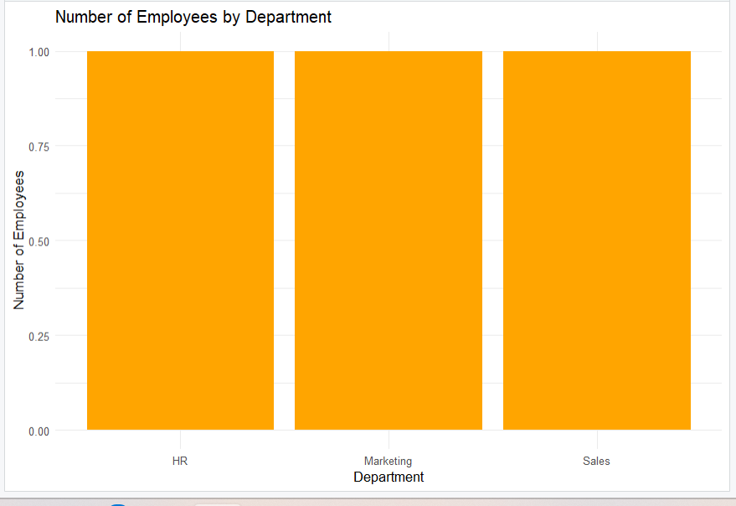
Output 2: Employees by Department Bar Chart
Observation: The bar chart shows one employee in each department: Sales, HR, and Marketing.

PROGRAM 3: Table of Employee Performance Data
Build a table to display the performance data for each employee.
employee_table <- data.frame(
Employee_ID = c(1, 2, 3),
Department = c("Sales", "HR", "Marketing"),
Years_Service = c(5, 3, 7),
Performance_Score = c(85, 92, 78)
)

print(employee_table)
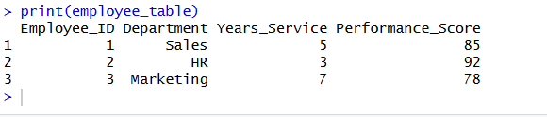
Output 3: Employee Performance Table
Observation: The table displays employee IDs, departments, years of service, and performance scores.

PROGRAM 4: Tableau Dashboard for Employee Performance
Procedure
- Open Tableau and connect to the Employee Performance dataset.
- Create a line chart using Years of Service and Performance Score.
- Create a bar chart using Department and Number of Records.
- Create a table containing Employee ID, Department, Years of Service, and Performance Score.
- Create a new Dashboard in Tableau.
- Add the line chart, bar chart, and table to the dashboard.
- Arrange the visualizations properly.
- Add filters for Department and Years of Service.
- Give the dashboard the title “Employee Performance Dashboard”.
- Save the Tableau dashboard.

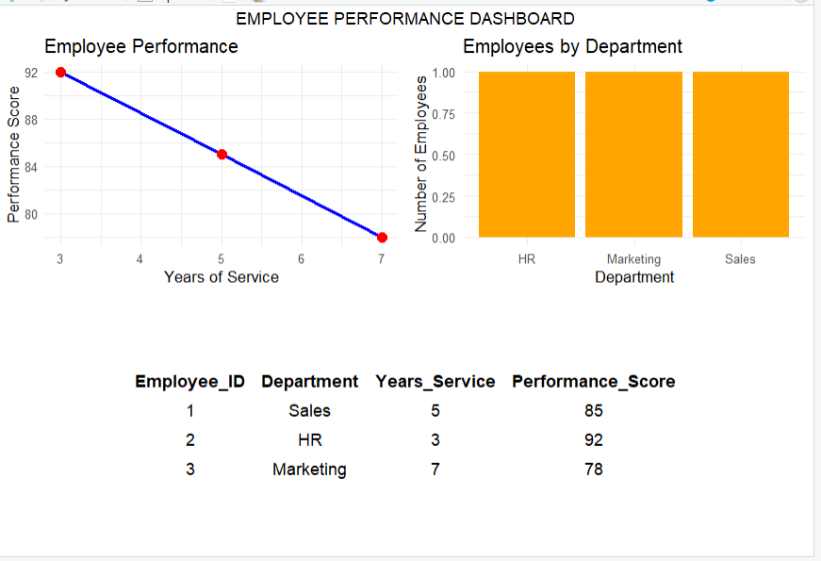
Output: Employee Performance Dashboard
Observation: The dashboard combines the performance chart, department bar chart, and employee table. It helps users compare employee performance and department distribution.

Set 17 Procedure
- Create an employee dataset containing employee ID, department, years of service, and performance score.
- Use R to create a line chart comparing performance scores with years of service.
- Create a bar chart showing the number of employees in each department.
- Create a table displaying the performance data for each employee.
- Import the employee dataset into Tableau.
- Create the line chart, bar chart, and table in Tableau.
- Combine the visualizations into a dashboard for interactive exploration.
Set 17 Result
Employee performance data was successfully visualized using a line chart, bar chart, and table. A Tableau dashboard was designed to provide a clear view of employee performance and department distribution.

